**Lesson 1 Demo 2**

**Create a New Gradle Project for Agrofarm**

|  |
| --- |
| **Objective:** To create a new Gradle project for a Agro farm  **Tools required:** Ubuntu and Eclipse IDE  **Prerequisites:** Gradle |

Steps to be followed:

1. Creating a new Gradle Project for a Agro farm

**Step 1: Creating a new Gradle Project for a Agro farm**

1. Open **Eclipse IDE** and navigate to **File** > **New** > **Project**

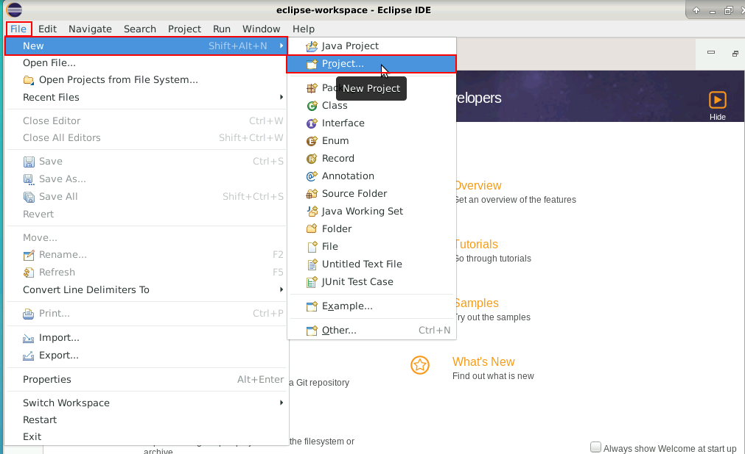

1. Click on **Gradle** > **Gradle Project** and then on the **Next** button

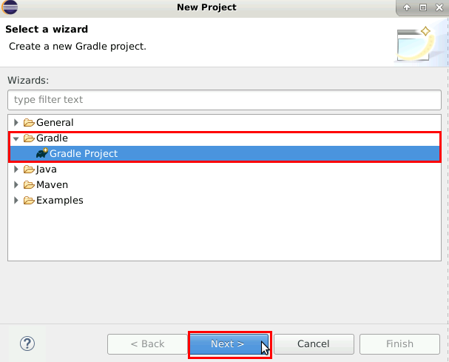

1. Name the project as **Agrofarm** and uncheck the **Use default location** box and click on **Next**

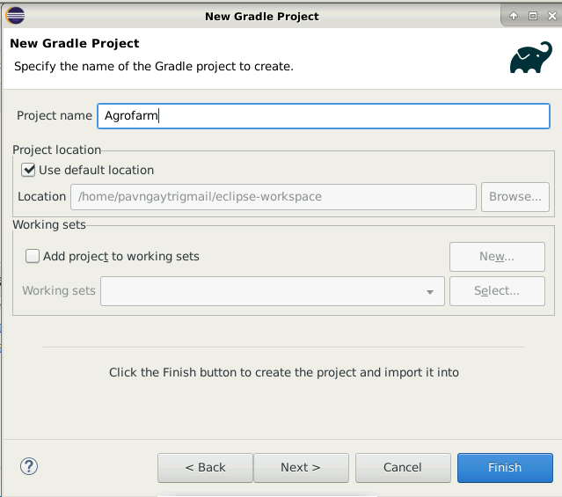

1. Click on **Overrideworkspace settings** and specify **7.4.2** in **Specific Gradle Version** and click **finish**

1. In the **Agrofarm** project, find the **build.gradle** file and open it. Add the following code and save it:

***/\****

***\* This file was generated by the Gradle 'init' task.***

***\****

***\* This generated file contains a sample Java Library project to get you started.***

***\* For more details take a look at the Java Libraries chapter in the Gradle***

***\* User Manual available at https://docs.gradle.org/6.3/userguide/java_library_plugin.html***

***\*/***

***plugins {***

***id 'checkstyle'***

***// Apply the java-library plugin to add support for Java Library***

***id 'java-library-distribution'***

***}***

***group '* Agrofarm *'***

***version '1.0'***

***repositories {***

***// Use jcenter for resolving dependencies.***

***// You can declare any Maven/Ivy/file repository here.***

***maven {***

***url "https://hyperledger.jfrog.io/hyperledger/fabric-maven"***

***}***

***jcenter()***

***maven {***

***url 'https://jitpack.io'***

***}***

***}***

***dependencies {***

***compileOnly 'org.hyperledger.fabric-chaincode-java:fabric-chaincode-shim:2.2.+'***

***implementation 'com.owlike:genson:1.5'***

***// This dependency is exported to consumers, that is to say found on their compile classpath.***

***api 'org.apache.commons:commons-math3:3.6.1'***

***// This dependency is used internally, and not exposed to consumers on their own compile classpath.***

***implementation 'com.google.guava:guava:28.2-jre'***

***// Use JUnit test framework***

***testImplementation 'junit:junit:4.12'***

***}***

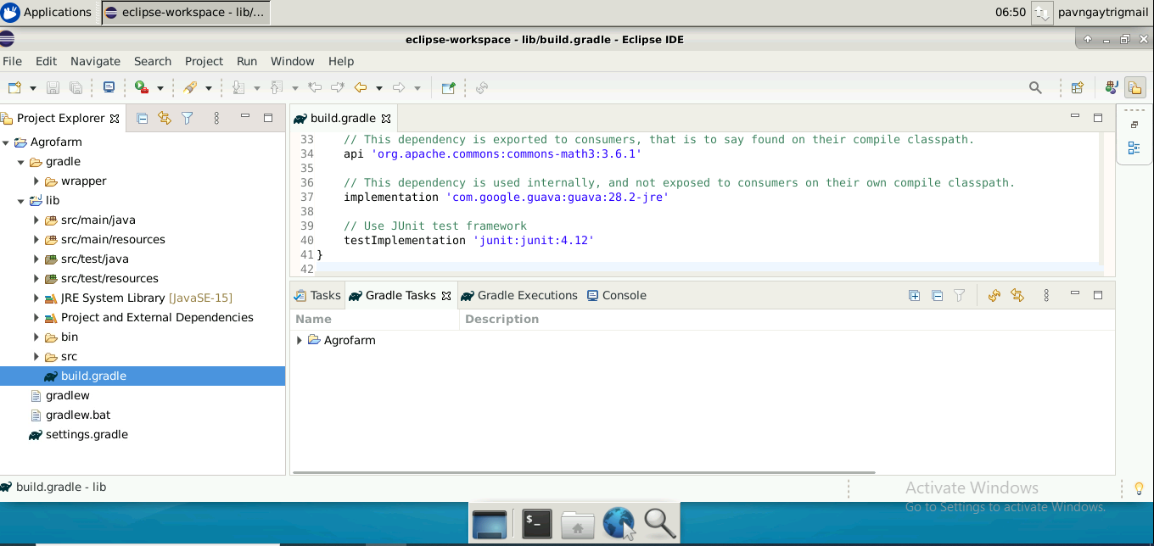

1. To download these dependencies, right-click on the **Agrofarm** project, go to **Gradle**,and click on **Refresh Gradle Project**

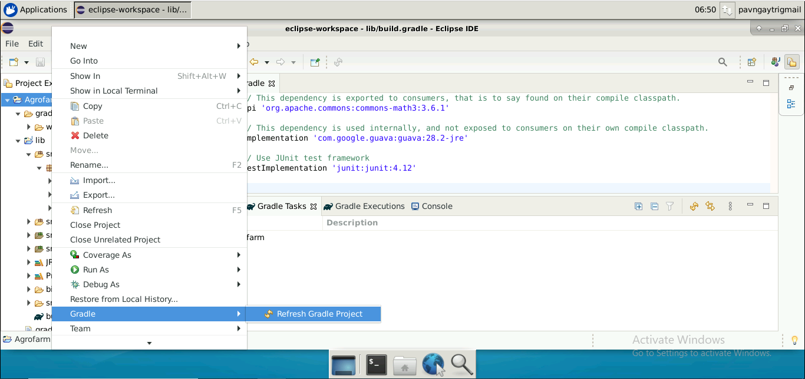

|  |
| --- |
| **Note**: A new Gradle project file for the Agro farm is created. |